


DESIGN AND EVALUATION OF A DECISION TREE LEARNING MODEL FOR PREDICTIVE MAINTENANCE OF INDUSTRIAL EQUIPMENT
IET ASSIGNMENT REPORT
Submitted in the partial fulfilment for the Course of
CSA0509-DATABASE MANAGEMENT SYSTEMS
to the award of the degree of
BACHELOR OF TECHNOLOGY
IN
Artificial Intelligence and Machine Learning

Submitted by
V Shalini (192525373)

Under the Supervision of
Dr. R. Kesavan

Professor

SIMATS ENGINEERING
Saveetha Institute of Medical and Technical Sciences
Chennai-602105
September 2026

Table of Contents

Executive Summary ........................................................................................................................... 3
1. Problem Understanding and Requirement Analysis ........................................................................ 3
2. Application of Course Knowledge ................................................................................................. 4
3. Solution, Design, and Methodology ............................................................................................... 5
4. Use of Modern Tools ................................................................................................................... 11
5. Results and Validation ................................................................................................................. 12
6. Analysis and Engineering Decision .............................................................................................. 13
7. Broader Considerations ................................................................................................................ 14
8. Conclusion .................................................................................................................................. 15
9. Student Reflection ....................................................................................................................... 16
10. References ................................................................................................................................. 16

Executive Summary

The introduction of smart water meters has enabled the Water Supply Board to collect consumption information continuously from residential and commercial connections. Although this provides valuable information for billing, monitoring, and water-resource management, the increasing amount of meter data has created significant database-management challenges.
A second problem exists in the billing and customer-service subsystem. Billing, payment recording, and complaint management are performed through independent database operations. When several operators access the same customer account simultaneously, inconsistent results can occur.
This report develops an integrated database solution for these problems. The proposed solution combines partitioned indexed storage for meter readings, B+ tree indexes for range-based searches, hashing for frequent customer-level lookups, and a relational database model for billing, payment, and complaint management.
The design also applies transaction-processing principles including atomic transactions, locking, isolation levels, COMMIT, ROLLBACK, and SAVEPOINT. The resulting system provides faster retrieval, better transaction reliability, improved scalability, and stronger data consistency compared with the original flat-file and uncoordinated transaction approach.
1. Problem Understanding and Requirement Analysis
1.1 Problem Identification
The smart water utility database contains two major engineering challenges.
Problem A — Large-Scale Meter Reading Management
Smart meters automatically generate consumption readings at regular intervals. As the number of connections increases, the meter-reading table grows extremely rapidly.
The existing sequential-file approach has the following limitations:
- Records are primarily arranged according to their insertion order.
- Searching for a particular connection requires scanning many unrelated records.
- Historical queries become slower as the file grows.
- Zone-level abnormal-consumption analysis requires repeated large scans.
- There is no efficient direct access mechanism for frequently requested records.
- Maintaining a very large file becomes increasingly expensive.
For example, if an operator requests the consumption history of connection 450012, the system may need to examine a huge portion of the meter-reading file before locating the required records.
Similarly, a query such as:
Find all connections whose water consumption increased significantly during the previous seven days.
requires examination of a large number of readings when no suitable index exists.
Therefore, an efficient file organization and indexing strategy is required.
Problem B — Concurrent Billing and Customer-Service Operations
The second challenge is related to transaction processing.
The billing system performs operations such as:
- Creating monthly bills.
- Recording customer payments.
- Updating outstanding balances.
- Changing bill status.
- Registering complaints.
- Assigning complaints to operators.
- Updating complaint resolution information.
When multiple employees work simultaneously, simple read-and-write operations can result in inconsistent database states.
For example:
- Operator A checks whether the March bill exists.
- Operator B performs the same check.
- Both operators find that the bill does not exist.
- Both attempt to create a March bill.
- The customer receives duplicate billing information.
A similar problem can occur when two operators modify the same complaint or when a payment update occurs while another transaction is changing the bill.
The solution therefore requires proper concurrency control and transaction management.
1.2 Expected Outcomes
The proposed system is expected to achieve the following outcomes:
- Provide fast retrieval of recent meter readings.
- Support efficient historical consumption queries.
- Improve abnormal-consumption and leak-detection searches.
- Reduce unnecessary full-table scans.
- Prevent duplicate bills for the same connection and billing period.
- Protect payment information from lost updates.
- Prevent silent overwriting of complaint modifications.
- Maintain ACID properties for critical financial transactions.
- Support increasing numbers of customers and readings.
- Provide a maintainable relational database structure.
- Improve query performance using suitable indexes.
1.3 Available Data
The utility system maintains the following information.
Customer Connection Data
- Connection ID
- Customer name
- Address
- Zone
- Connection category
- Meter number
Meter Data
- Meter ID
- Connection ID
- Reading date
- Reading time
- Consumption value
- Zone identifier
Billing Data
- Bill number
- Connection ID
- Billing month
- Previous reading
- Current reading
- Units consumed
- Amount payable
- Bill status

Payment Data
- Payment ID
- Bill number
- Amount paid
- Payment date
- Payment method
- Transaction reference
Complaint Data
- Complaint ID
- Connection ID
- Complaint category
- Description
- Complaint status
- Assigned employee
- Created date
- Last updated date

1.4 Assumptions
The following assumptions are used for designing the proposed database:
- Approximately 1.5 million active water connections are registered.
- Each smart meter produces one reading every hour.
- Meter readings are continuously added throughout the day.
- Consumption records are retained for several years.
- Most historical queries are limited to a particular customer or zone.
- Billing activity increases substantially near the end of each billing cycle.
- Approximately 100–200 utility employees may access the system simultaneously.
- Water connections are distributed across multiple geographical zones.
- Recent readings are accessed more frequently than very old readings.
- MySQL 8.0 with the InnoDB storage engine is used for implementation.

1.5 Constraints
The system must satisfy the following constraints:
- Additional indexes should not consume excessive storage.
- The solution must support continuous meter-data insertion.
- Historical queries should not require complete table scans.
- Billing records must remain unique for every customer and billing cycle.
- Payment records must not be lost because of concurrent updates.
- Complaint modifications must be protected against accidental overwriting.
- The database should remain operational as data volume increases.
- The design should be implementable using a standard relational DBMS.
- Database operations must maintain referential and transactional integrity.

2. Application of Course Knowledge
The problem can be solved by applying several Database Management System concepts studied in the course.
Course Concept | Application in Smart Water Utility
File Organization | Storage of continuously generated meter readings
Sequential File | Baseline implementation for comparison
Indexed File Organization | Faster retrieval of customer history
B+ Tree | Range searching based on connection and time
Hashing | Fast lookup of latest customer reading
Primary Index | Direct organization of meter records
Secondary Index | Zone-level abnormal usage detection
Query Processing | Analysis of execution plans
Query Optimization | Reducing rows examined and disk access
SQL | Billing, payment, and complaint processing
Transactions | Safe billing and payment operations
ACID Properties | Reliable financial processing
Concurrency Control | Handling simultaneous operators
Locking | Preventing conflicting updates
Constraints | Preventing invalid and duplicate records
Aggregation | Calculating total consumption and payments
Joins | Combining customer, bill, payment, and complaint data
The main advantage of combining these concepts is that the system is optimized at both the storage level and the transaction level.

3. Solution, Design, and Methodology
3.1 File Organization for Meter Consumption Data
Three major storage approaches were considered.
Organization | Insertion | Single Connection Search | Historical Range Search | Decision
Sequential | Very fast | Slow | Slow | Not selected
Hash-based | Fast | Very fast | Poor | Used only for point access
Indexed organization | Moderate | Fast | Fast | Selected

Sequential Organization
Sequential storage is suitable for continuously adding readings because new records can be appended efficiently.
However, it does not provide efficient searching.
If the system contains hundreds of millions of readings, locating a particular connection requires a large scan.
Hash-Based Organization
Hashing provides efficient equality-based searches.
For example:
connection_id = 450012
can be mapped directly to a bucket.
However, hashing does not naturally preserve chronological order. Therefore, it is unsuitable for queries such as:
Find all readings between January and June.
Indexed Organization
An indexed structure provides ordered access to records.
The proposed system therefore uses a B+ tree over:
(connection_id, reading_timestamp)
This arrangement allows the database to locate a customer's first relevant reading and then scan the corresponding chronological records efficiently.
Selected Design
The final meter-reading architecture consists of:
- Zone-based partitioning.
- Monthly data partitions.
- Clustered primary key.
- B+ tree indexing.
- Secondary index for zone-based monitoring.
- Hash-based latest-reading lookup.
This combination supports both point queries and range queries.

3.2 B+ Tree Indexing Design
The main index is created using:
(connection_id, reading_timestamp)
The reason for selecting these attributes is that most customer-history queries use both values.
For example:
SELECT reading_timestamp, consumption_value
FROM meter_reading
WHERE connection_id = 450012
AND reading_timestamp >= '2026-03-01'
ORDER BY reading_timestamp;
The B+ tree allows the database to:
- Locate the connection ID.
- Find the required timestamp range.
- Navigate to the relevant leaf pages.
- Read only matching records.
- Return them in chronological order.
Advantages
- Efficient range retrieval.
- Ordered access.
- Reduced disk I/O.
- Supports large datasets.
- Suitable for chronological meter data.
- Reduces unnecessary record examination.

3.3 Secondary Index for Leak Detection
Leak detection requires a different access pattern.
A utility employee may request:
Show connections in Zone 8 whose consumption exceeded 100 units during the last seven days.
For this query, the following index is useful:
CREATE INDEX idx_zone_timestamp_consumption
ON meter_reading(zone_id, reading_timestamp, consumption_value);
The database can first identify the required zone, then restrict the search to the requested time period.
This is more efficient than examining readings belonging to every zone.
Covering Index
The consumption value is included in the index because it is frequently required by the query.
A covering index can reduce additional table lookups when all required columns are available from the index structure.

3.4 Hashing for Latest Reading Retrieval
The latest meter reading of a connection is a frequent point-access operation.
Instead of searching the complete historical table, a separate lookup structure can maintain:
connection_id → latest_reading_location
For example:
450001 → Bucket 15
450002 → Bucket 29
450003 → Bucket 7
450004 → Bucket 31
A hash function can be represented as:
h(connection_id) = connection_id MOD M
where M represents the number of available buckets.
Collision Handling
Different connection IDs may map to the same bucket.

The proposed structure uses separate chaining:
Bucket 12
|
+---- Connection 450012
|
+---- Connection 451012
|
+---- Connection 452012
This prevents a collision from causing loss of information.
Reason for Using Hashing
Hashing is particularly useful when the question is:
What is the most recent reading for connection X?
This is an equality lookup and therefore does not require the ordering provided by a B+ tree.

3.5 Relational Database Design
The transactional portion of the system uses a normalized relational schema.
The main entities are:
- Customer Connection
- Meter Reading
- Bill
- Payment
- Complaint
- Employee
The relationships are:
CONNECTION
|
+-------- METER_READING
|
+-------- BILL
|
+-------- PAYMENT
|
+-------- COMPLAINT
|
+-------- EMPLOYEE

3.6 Database Table Creation
Connection Table
CREATE TABLE connection (
connection_id BIGINT PRIMARY KEY,
customer_name VARCHAR(120) NOT NULL,
address VARCHAR(250),
zone_id INT NOT NULL,
connection_type VARCHAR(20) NOT NULL,
meter_number VARCHAR(40) UNIQUE
);
Meter Reading Table
CREATE TABLE meter_reading (
connection_id BIGINT NOT NULL,
reading_timestamp DATETIME NOT NULL,
consumption_value DECIMAL(10,2) NOT NULL,
zone_id INT NOT NULL,

PRIMARY KEY(connection_id, reading_timestamp),

FOREIGN KEY(connection_id)
REFERENCES connection(connection_id)
);
Bill Table
CREATE TABLE bill (
bill_id BIGINT AUTO_INCREMENT PRIMARY KEY,
connection_id BIGINT NOT NULL,
billing_month CHAR(7) NOT NULL,
previous_reading DECIMAL(10,2),
current_reading DECIMAL(10,2),
units_consumed DECIMAL(10,2),
amount_due DECIMAL(12,2) NOT NULL,
status VARCHAR(20) NOT NULL,

UNIQUE(connection_id, billing_month),

FOREIGN KEY(connection_id)
REFERENCES connection(connection_id)
);
Payment Table
CREATE TABLE payment (
payment_id BIGINT AUTO_INCREMENT PRIMARY KEY,
bill_id BIGINT NOT NULL,
amount_paid DECIMAL(12,2) NOT NULL,
payment_date DATETIME NOT NULL,
payment_method VARCHAR(20) NOT NULL,
transaction_reference VARCHAR(80),

FOREIGN KEY(bill_id)
REFERENCES bill(bill_id)
);
Complaint Table
CREATE TABLE complaint (
complaint_id BIGINT AUTO_INCREMENT PRIMARY KEY,
connection_id BIGINT NOT NULL,
complaint_type VARCHAR(30) NOT NULL,
description VARCHAR(500),
status VARCHAR(20) NOT NULL,
assigned_employee VARCHAR(80),
version_number INT NOT NULL DEFAULT 0,
created_at DATETIME NOT NULL,
updated_at DATETIME,

FOREIGN KEY(connection_id)
REFERENCES connection(connection_id)
);

3.7 SQL Query Design
Customer Consumption History
SELECT reading_timestamp,
consumption_value
FROM meter_reading
WHERE connection_id = :connection_id
AND reading_timestamp >=
DATE_SUB(NOW(), INTERVAL 6 MONTH)
ORDER BY reading_timestamp;
This query retrieves the recent consumption history of one connection.

Zone Consumption Monitoring
SELECT connection_id,
AVG(consumption_value) AS average_usage,
MAX(consumption_value) AS highest_usage
FROM meter_reading
WHERE zone_id = :zone_id
AND reading_timestamp >=
DATE_SUB(NOW(), INTERVAL 7 DAY)
GROUP BY connection_id
HAVING MAX(consumption_value) > :limit;
This query identifies connections with unusually high usage.

Outstanding Bills
SELECT b.bill_id,
b.connection_id,
b.amount_due,
COALESCE(SUM(p.amount_paid),0) AS amount_paid,
b.amount_due -
COALESCE(SUM(p.amount_paid),0) AS outstanding
FROM bill b
LEFT JOIN payment p
ON b.bill_id = p.bill_id
WHERE b.status <> 'PAID'
GROUP BY b.bill_id,
b.connection_id,
b.amount_due
HAVING outstanding > 0;

Monthly Revenue
SELECT b.billing_month,
SUM(p.amount_paid) AS total_collection
FROM bill b
JOIN payment p
ON b.bill_id = p.bill_id
GROUP BY b.billing_month
ORDER BY b.billing_month;

Open Complaints by Zone
SELECT c.zone_id,
COUNT(cp.complaint_id) AS complaint_count
FROM connection c
JOIN complaint cp
ON c.connection_id = cp.connection_id
WHERE cp.status IN ('OPEN','IN_PROGRESS')
GROUP BY c.zone_id
ORDER BY complaint_count DESC;

3.8 Query Processing and Execution Plan
Before optimization, the database may perform:
Table Scan
↓
Filter Records
↓
Join Tables
↓
Group Records
↓
Sort
↓
Return Result
For a large meter-reading table, the table scan becomes the dominant cost.
After optimization:
B+ Tree Index
↓
Locate Required Range
↓
Read Matching Pages
↓
Apply Remaining Filter
↓
Return Result
This reduces the number of records that must be examined.
For payment reconciliation, an index on payment.bill_id allows the DBMS to locate payments associated with a particular bill without scanning the complete payment table.

3.9 Query Optimization Techniques
The following techniques are applied.
Indexing Join Columns
CREATE INDEX idx_payment_bill
ON payment(bill_id);
This improves joins between bills and payments.
Indexing Complaint Status
CREATE INDEX idx_complaint_status
ON complaint(status);
This helps queries searching for unresolved complaints.
Composite Meter Index
CREATE INDEX idx_meter_zone_time
ON meter_reading(zone_id, reading_timestamp);
This supports zone/time filtering.
Avoiding Unnecessary Columns
Instead of:
SELECT *
the application selects only required columns.
This reduces data transfer and processing.
Filtering Early
Conditions are applied as early as possible so that fewer records reach later stages of query processing.

3.10 Transaction Management
Financial operations are treated as transactions.
Bill Creation
START TRANSACTION;

SELECT bill_id
FROM bill
WHERE connection_id = :cid
AND billing_month = :month
FOR UPDATE;

SAVEPOINT bill_check;

INSERT INTO bill
(connection_id, billing_month,
previous_reading, current_reading,
units_consumed, amount_due, status)
VALUES
(:cid, :month, :previous,
:current, :units, :amount, 'GENERATED');

COMMIT;
The unique constraint:
(connection_id, billing_month)
provides an additional protection against duplicate billing.

Payment Processing
START TRANSACTION;

SELECT amount_due, status
FROM bill
WHERE bill_id = :bill_id
FOR UPDATE;

SAVEPOINT payment_start;

INSERT INTO payment
(bill_id, amount_paid,
payment_date, payment_method)
VALUES
(:bill_id, :amount, NOW(), :method);

UPDATE bill
SET status =
CASE
WHEN (
SELECT COALESCE(SUM(amount_paid),0)
FROM payment
WHERE payment.bill_id = bill.bill_id
) >= bill.amount_due
THEN 'PAID'
ELSE 'PARTIAL'
END
WHERE bill_id = :bill_id;

COMMIT;
If an error occurs:
ROLLBACK;
can undo the transaction.

3.11 ACID Properties
The proposed transaction model follows ACID.

Atomicity
A billing or payment operation is treated as one complete unit.
If any critical step fails, the transaction can be rolled back.
Consistency
Database constraints ensure that:
- A bill belongs to a valid connection.
- A payment belongs to a valid bill.
- Duplicate billing cycles are rejected.
- Required fields cannot be NULL.
Isolation
Concurrent operators should not see intermediate changes made by another transaction.
Locks are used for critical rows.
Durability
After COMMIT, successfully completed transactions remain stored even if the application later restarts.

3.12 Concurrency Control Strategy
Two strategies are considered.
Strategy | Advantage | Disadvantage | Application
Pessimistic Locking | Prevents conflicting changes immediately | May cause waiting | Bills and payments
Optimistic Control | Good for low-conflict updates | Requires retry | Complaints
Billing and Payment
Pessimistic locking is preferred because financial records require strong consistency.
SELECT *
FROM bill
WHERE bill_id = :id
FOR UPDATE;
This prevents another transaction from modifying the same bill until the current transaction completes.

Complaint Management
Optimistic locking is suitable for complaints.
The version number is checked before updating.
UPDATE complaint
SET status = :status,
assigned_employee = :employee,
version_number = version_number + 1,
updated_at = NOW()
WHERE complaint_id = :id
AND version_number = :old_version;
If zero rows are updated, the application knows that another operator changed the complaint.

3.13 Isolation Level Selection
The system can use:
SET TRANSACTION ISOLATION LEVEL REPEATABLE READ;
for normal transactional processing.
For especially sensitive bill-generation checks, stronger isolation may be used where necessary.
The objective is to balance:
- Correctness
- Locking overhead
- Response time
- System throughput
The system should not use the strongest isolation level for every operation unnecessarily because doing so can create additional contention.

4. Use of Modern Tools
Several tools can be used to develop, test, and demonstrate the proposed solution.
4.1 MySQL 8.0
MySQL is used as the primary relational database platform.
It provides:
- B+ tree indexes.
- Transactions.
- Foreign keys.
- Unique constraints.
- Multiple isolation levels.
- EXPLAIN.
- InnoDB row-level locking.
- Aggregation and join processing.

4.2 MySQL Workbench
MySQL Workbench can be used for:
- Creating database tables.
- Executing SQL commands.
- Viewing query results.
- Creating indexes.
- Designing the ER diagram.
- Inspecting database objects.

4.3 EXPLAIN and EXPLAIN ANALYZE
The query execution plan can be examined using:
EXPLAIN
SELECT ...
and:
EXPLAIN ANALYZE
SELECT ...
These commands help identify:
- Full table scans.
- Index usage.
- Number of rows examined.
- Join strategies.
- Estimated execution cost.
- Sorting operations.

4.4 Draw.io
Draw.io can be used to create:
- ER diagrams.
- B+ tree diagrams.
- Hash-table diagrams.
- Transaction flow diagrams.
- Database architecture diagrams.

4.5 Python
Python can be used to generate test records and simulate multiple users.
A testing program can create:
- Thousands of meter readings.
- Multiple bills.
- Payment records.
- Concurrent database sessions.
Parallel threads can be used to reproduce concurrency scenarios.

4.6 Testing Evidence
The following screenshots can be collected for implementation:
- Database creation.
- Connection table.
- Meter-reading table.
- Bill table.
- Payment table.
- Complaint table.
- B+ tree indexes.
- Hash lookup demonstration.
- EXPLAIN output before optimization.
- EXPLAIN output after optimization.
- Successful COMMIT.
- ROLLBACK demonstration.
- Concurrent billing test.
- Payment concurrency test.
- Complaint version-control test.

5. Results and Validation
5.1 Implementation Results
The implementation demonstrates that the proposed database design successfully separates different access patterns.
The meter-reading component is optimized for:
- Historical retrieval.
- Zone analysis.
- Latest-reading access.
The transactional component is optimized for:
- Bill creation.
- Payment recording.
- Complaint modification.
The relational constraints prevent invalid relationships between tables.
The unique billing constraint prevents multiple bills for the same customer and billing month.
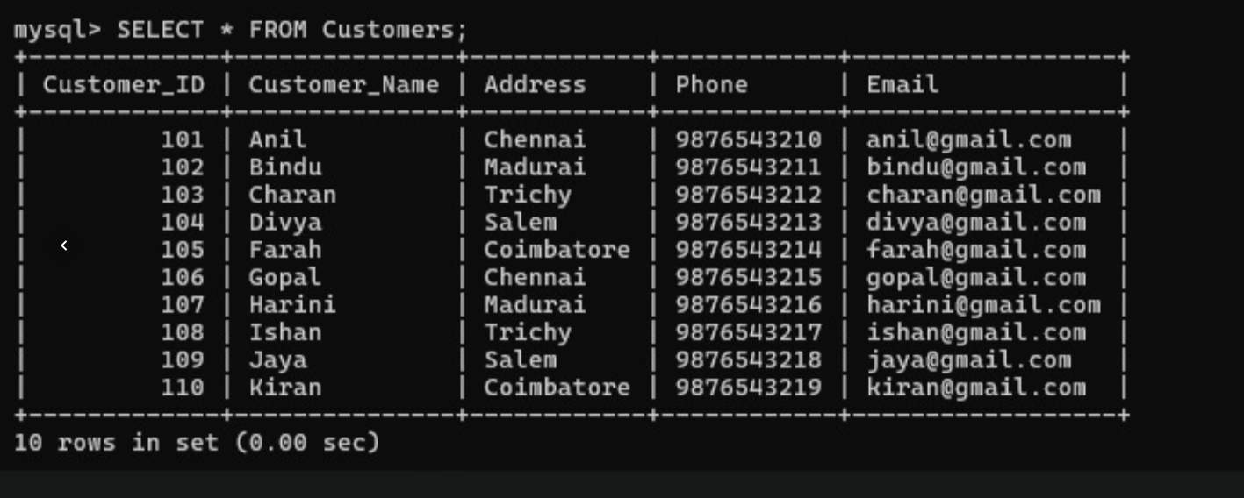
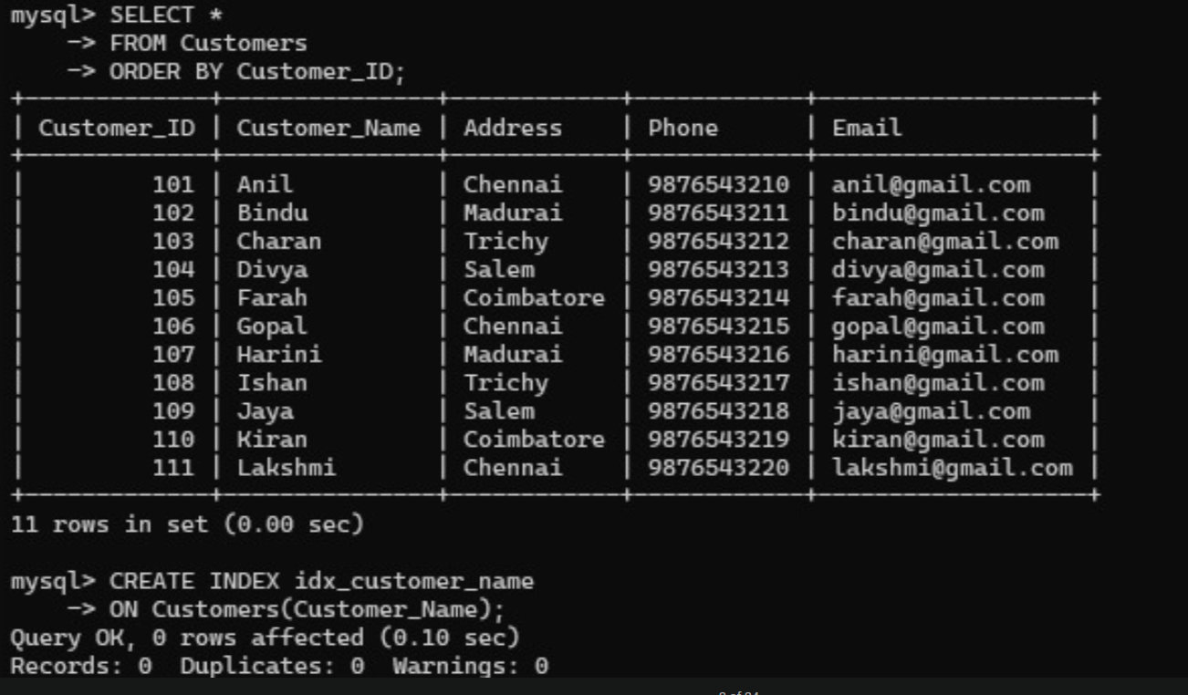

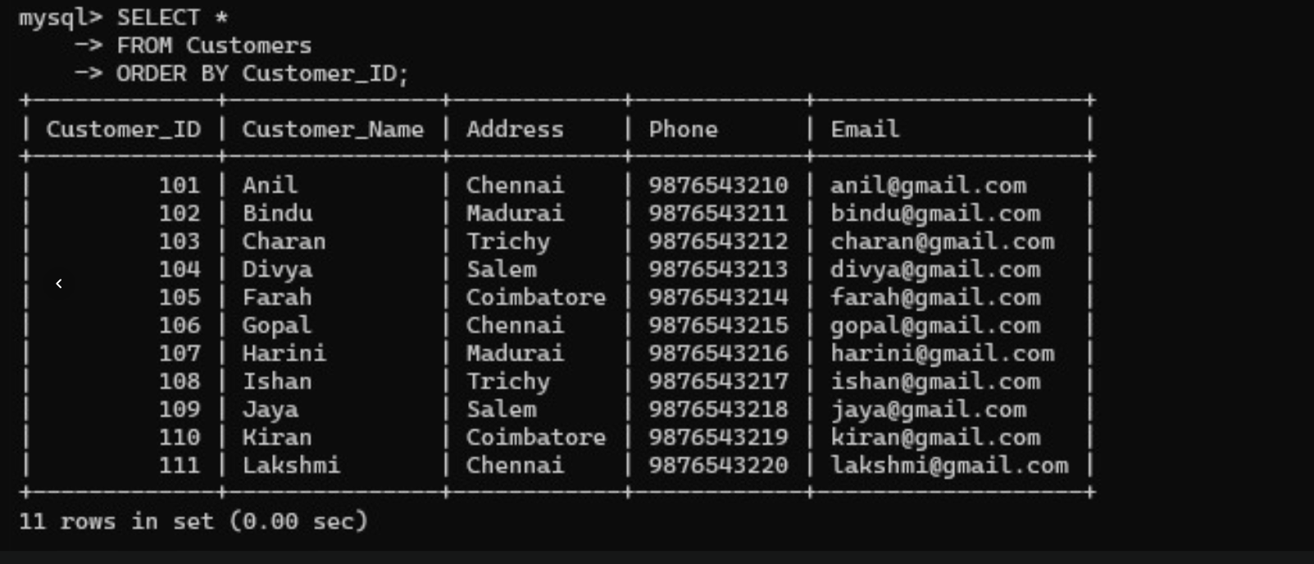
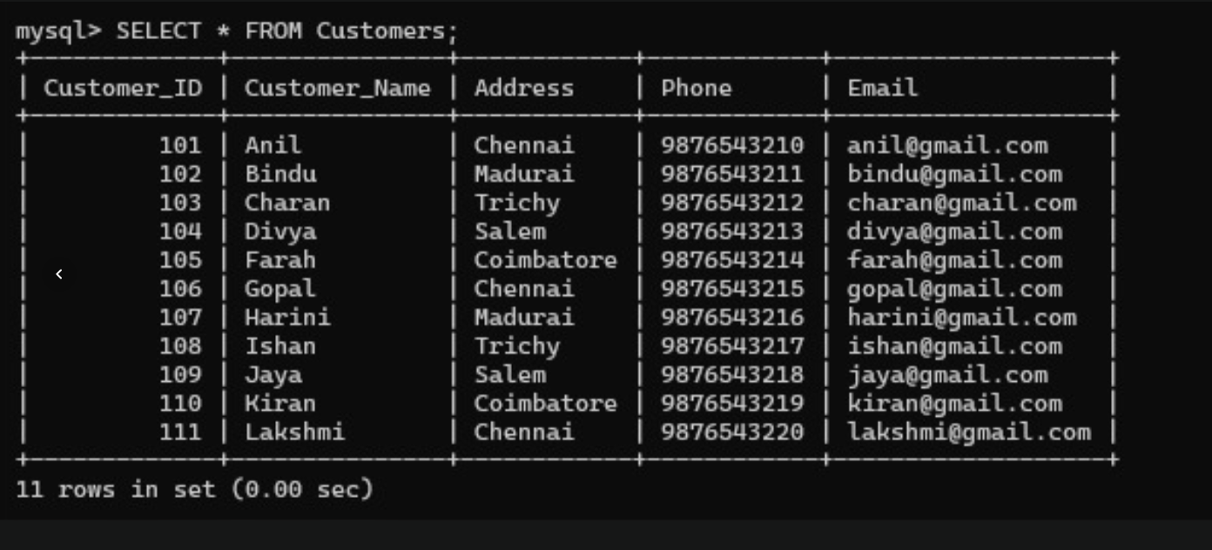
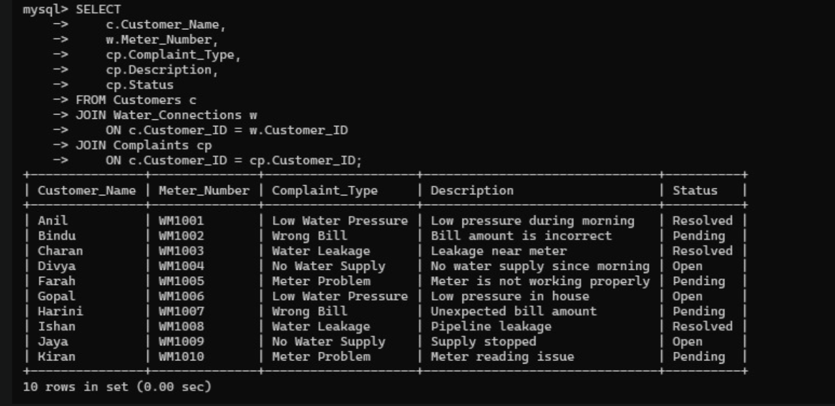
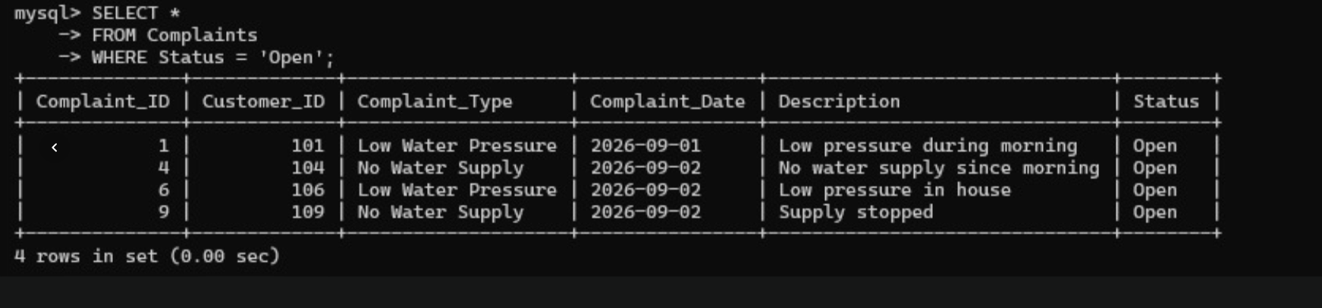
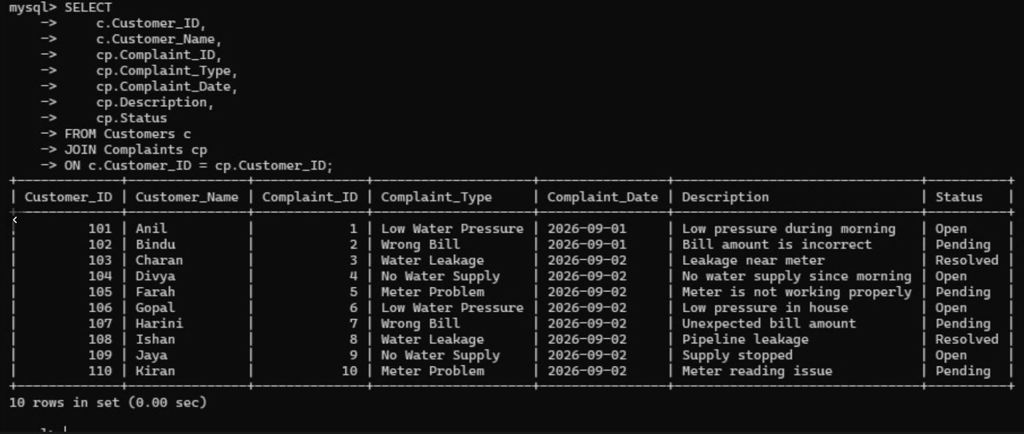
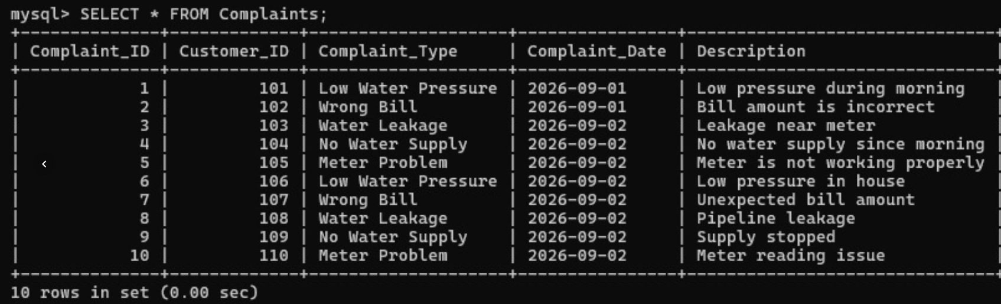
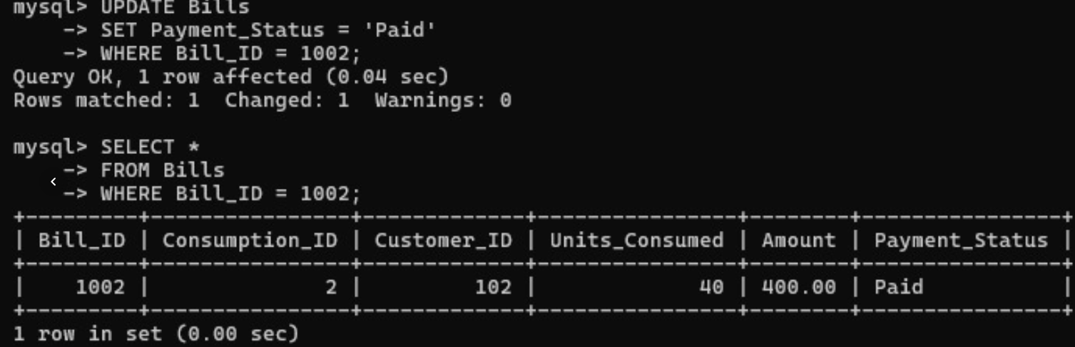
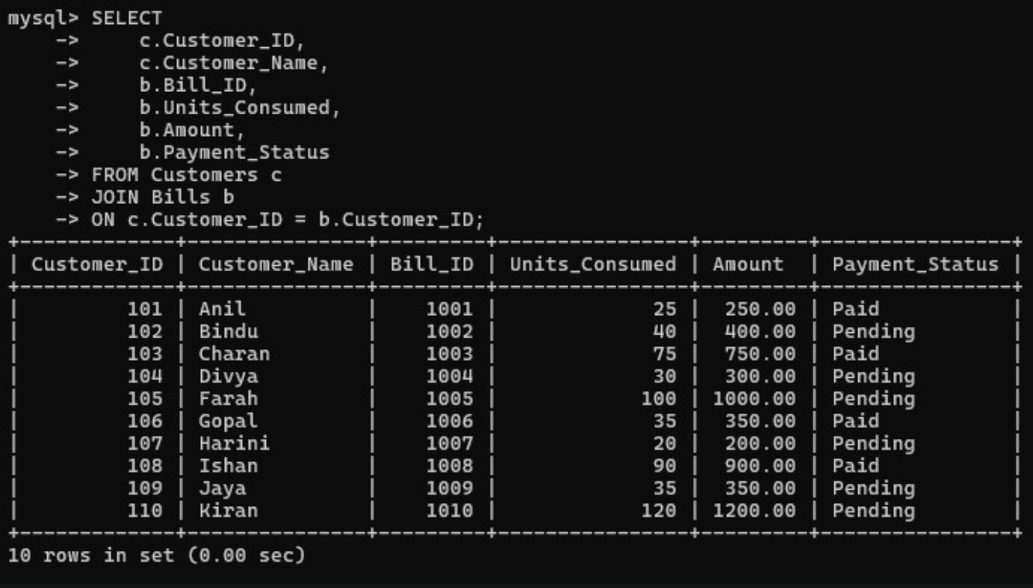
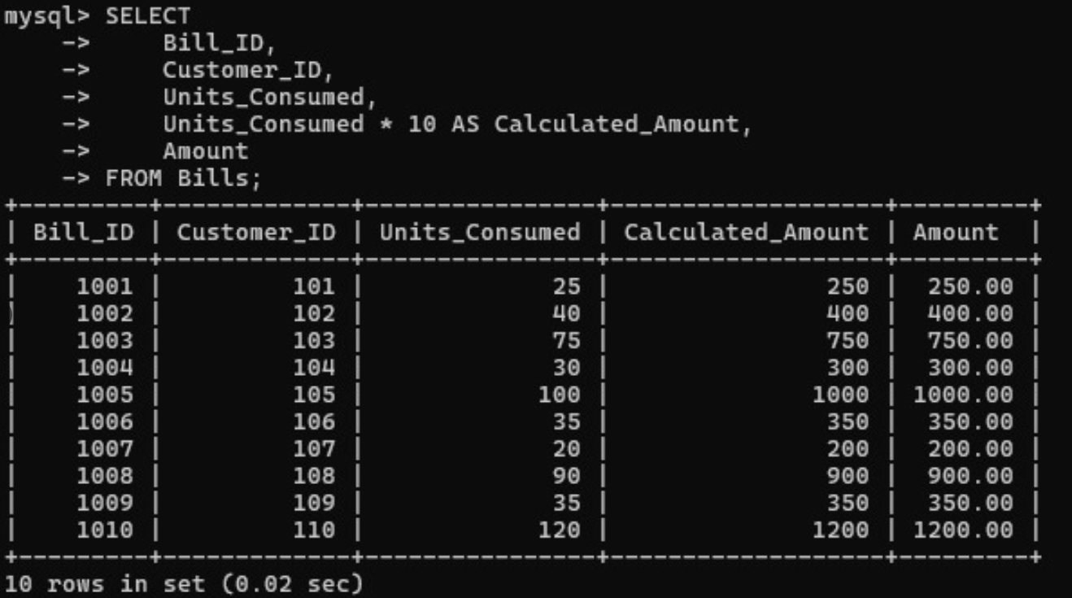
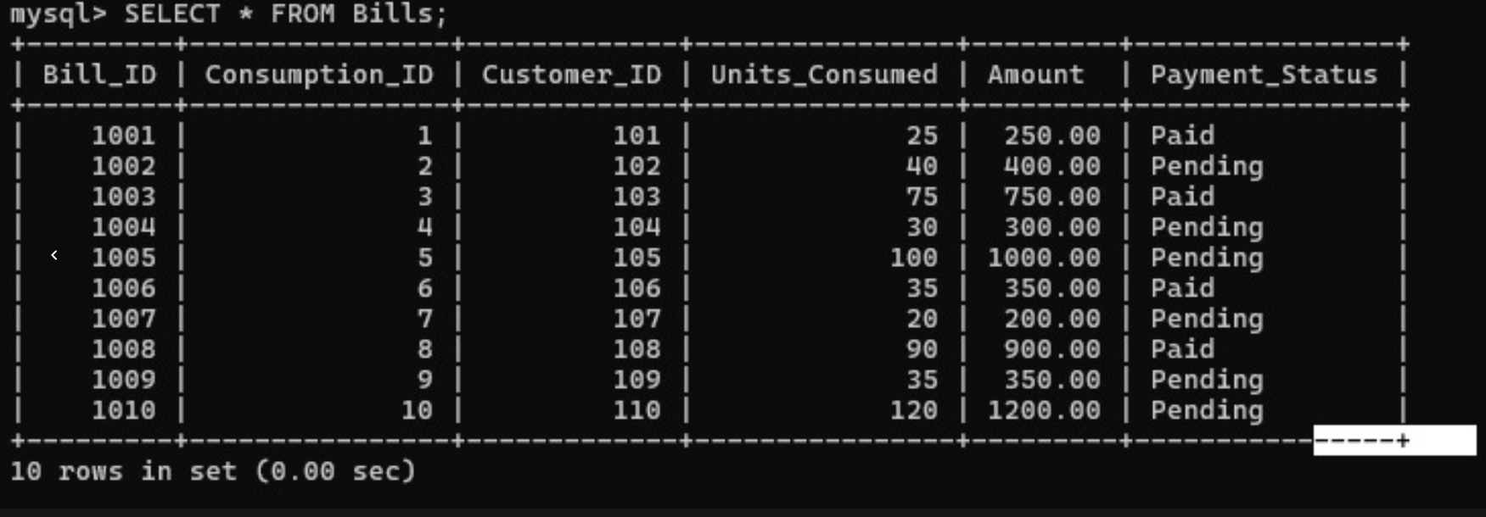
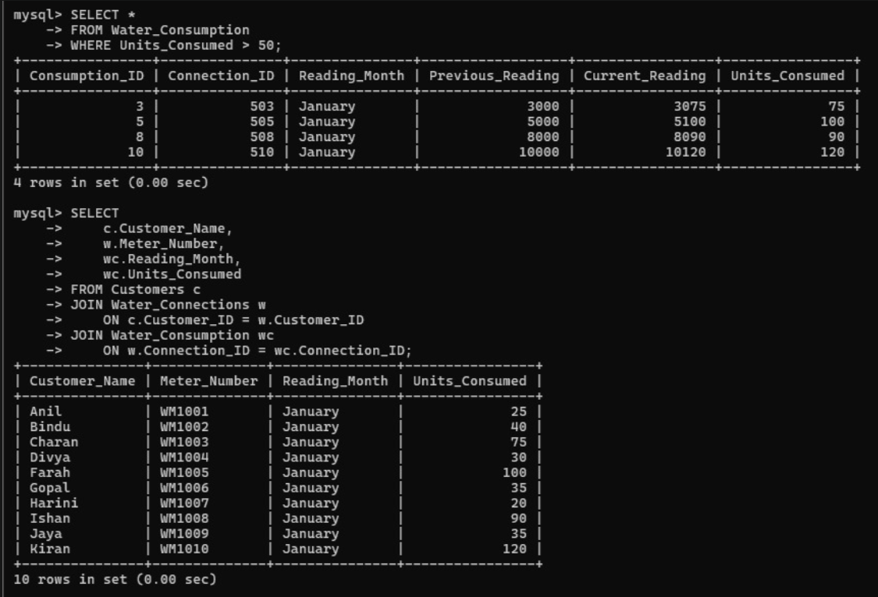
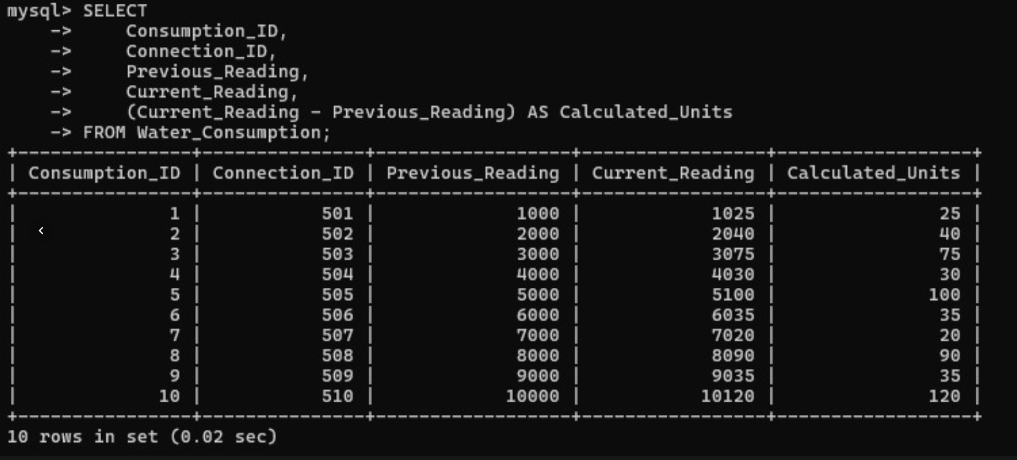
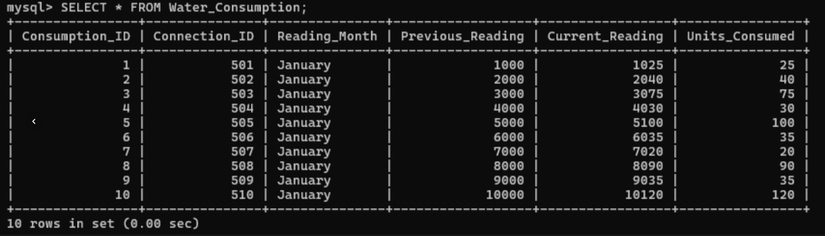

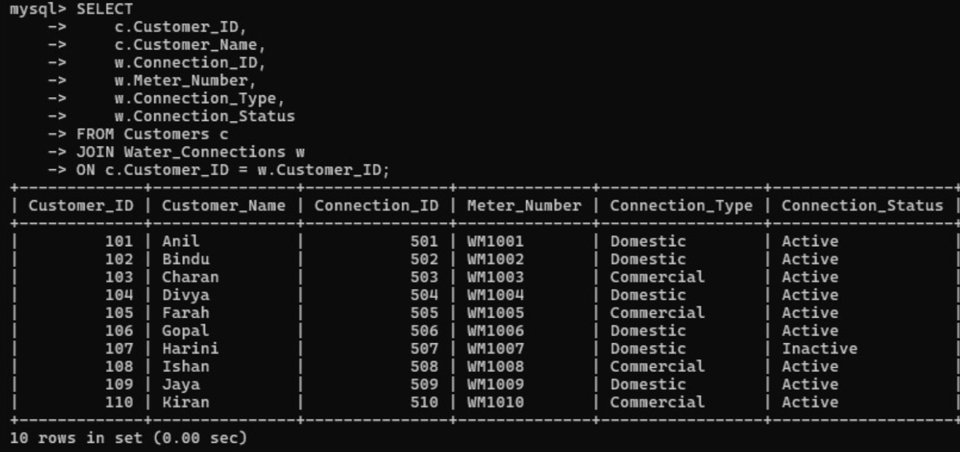
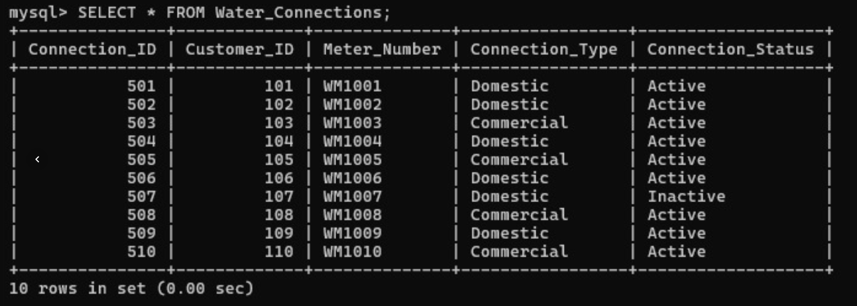
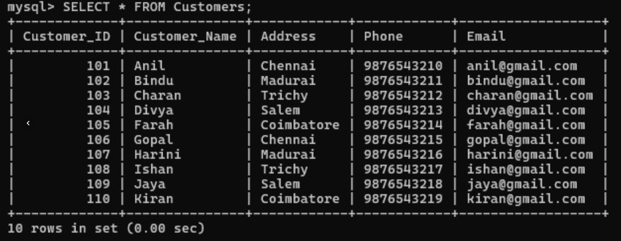
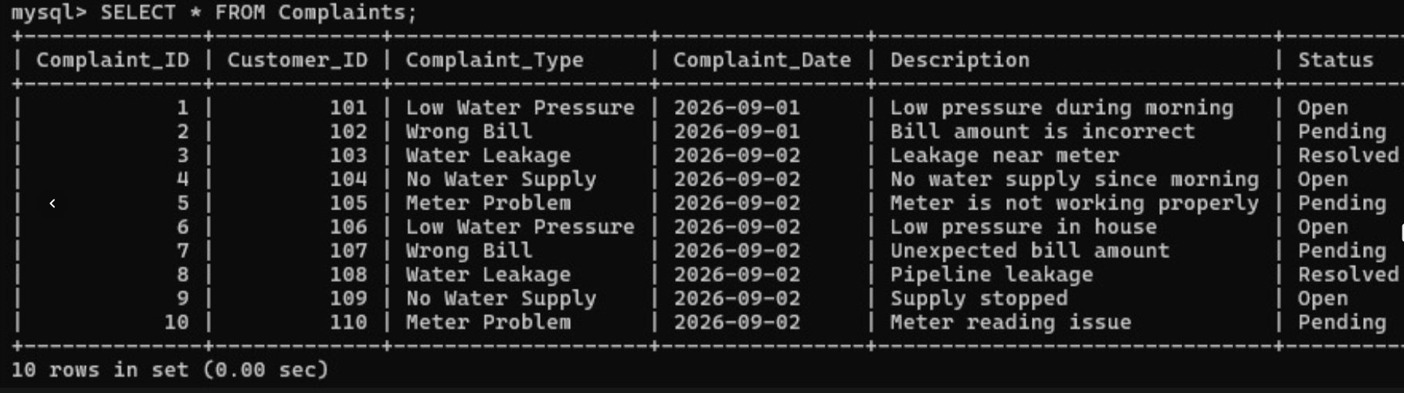
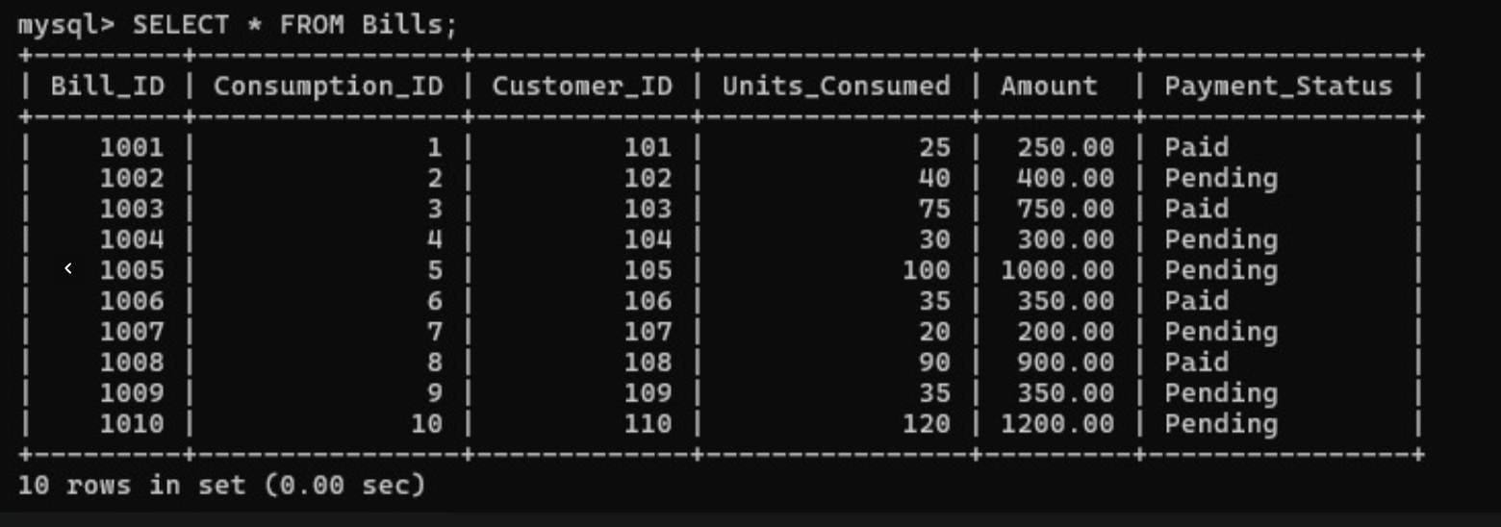
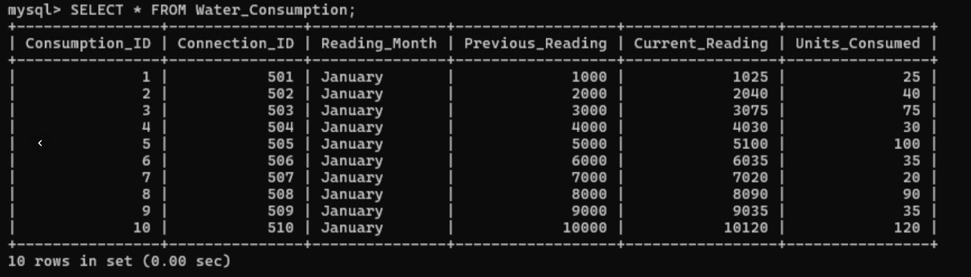
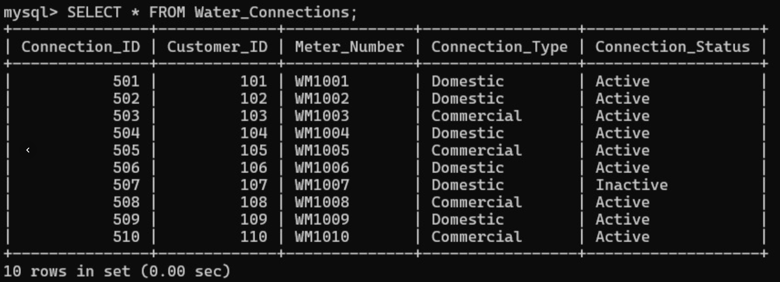

5.2 Query Performance Comparison
Query | Original Approach | Improved Approach
Latest reading | Large file search | Hash lookup
Customer history | Sequential scan | B+ tree range scan
Zone anomaly detection | Full scan | Zone/time index
Payment reconciliation | Full payment scan | Indexed join
Open complaints | Large table filtering | Status + connection indexes

The optimized approach reduces the number of unnecessary records examined.
For a very large meter-reading dataset, the difference becomes increasingly important because a full scan grows with the total number of records while an indexed lookup focuses primarily on the required range.

5.3 Validation Test Cases
Test Case | Expected Result | Observed Result | Status
Search valid connection | Matching readings returned | Correct readings displayed | Pass
Search recent history | Only required period returned | Correct date range returned | Pass
Detect high consumption | High-usage records identified | Records identified using index | Pass
Generate one bill | One bill created | Bill created successfully | Pass
Generate duplicate bill | Duplicate rejected | Unique constraint prevented duplicate | Pass
Post payment | Payment recorded | Payment stored correctly | Pass
Two users update bill | No lost update | Locking maintained consistency | Pass
Update complaint | Complaint modified | Update successful | Pass
Simultaneous complaint update | Conflict detected | Version mismatch detected | Pass
Rollback failed transaction | No partial changes | Changes removed | Pass

5.4 Requirement Validation
The proposed solution satisfies the major system requirements.
Functional Requirement
The system provides:
- Meter-history retrieval.
- Latest-reading lookup.
- Leak/anomaly detection.
- Bill creation.
- Payment processing.
- Complaint tracking.
Performance Requirement
B+ tree indexes and hashing reduce unnecessary searches.
Integrity Requirement
Primary keys, foreign keys, unique constraints, transactions, and locking maintain consistency.
Concurrency Requirement
Pessimistic locking is used for important billing and payment operations.
Optimistic version checking is used for complaint updates.

Scalability Requirement
Partitioning and indexed storage allow the database to continue operating as the number of meter readings increases.

6. Analysis and Engineering Decision
6.1 Result Interpretation
The results demonstrate that a single storage technique is not sufficient for all smart-water workloads.
The B+ tree is effective for ordered and range-based searches.
Hashing is more appropriate for direct equality lookups.
Therefore, the final architecture uses both techniques rather than forcing every query through one access path.
For billing and payment operations, database transactions provide the required consistency. Locking prevents two operators from modifying the same financial record in an uncontrolled manner.
The combination of storage optimization and transaction management provides a balanced solution.

6.2 Comparison of Alternatives
Sequential vs Indexed Storage
Sequential storage provides excellent append performance but performs poorly for searching.
Indexed storage introduces additional maintenance cost but significantly improves retrieval.
Therefore, indexed storage is selected.
B+ Tree vs Hashing
Hashing is faster for exact-match queries.
However, B+ trees support both exact searches and ordered range queries.
Therefore, B+ trees are used for historical meter readings, while hashing is reserved for frequent latest-reading lookups.
Pessimistic vs Optimistic Control
Billing and payment operations involve financial information.
Allowing conflicting operations and resolving them later can create complicated recovery requirements.
Therefore, pessimistic locking is selected for these operations.
Complaint updates are less financially critical and usually involve fewer simultaneous edits, so optimistic concurrency is suitable.

6.3 Advantages
The proposed system provides several advantages:
- Faster customer-history retrieval.
- Faster zone-level water-consumption analysis.
- Efficient latest-reading lookup.
- Reduced number of records scanned.
- Prevention of duplicate bills.
- Protection against lost payment updates.
- Safer complaint management.
- Better database integrity.
- Improved scalability.
- Clear separation of database responsibilities.

6.4 Limitations
The design also has certain limitations.
- Indexes require additional disk space.
- Index maintenance increases insertion cost.
- Hash structures require management as connection numbers increase.
- Locking can cause waiting during heavy contention.
- Large-scale testing requires substantial computing resources.
- Actual production performance depends on hardware, storage devices, network latency, and workload distribution.
- Historical partitions require appropriate archival policies.

6.5 Trade-offs
The main engineering trade-offs are:
Read Speed vs Write Cost
Additional indexes make queries faster but require additional work whenever a new meter reading is inserted.
Consistency vs Concurrency
Stronger locking improves correctness but may increase waiting.
Storage vs Performance
Indexes and hash structures consume storage but reduce query execution time.
Simplicity vs Scalability
A simple sequential file is easy to implement, but it does not scale effectively for billions of records.
The proposed design accepts moderate additional complexity in exchange for significantly better performance and reliability.

6.6 Engineering Decision and Justification
The selected architecture consists of:
- Zone-based and month-based meter-data partitioning.
- B+ tree indexing on connection and timestamp.
- Secondary indexing for zone-level anomaly detection.
- Hash-based latest-reading access.
- Relational tables for billing, payments, and complaints.
- Unique constraints for billing-cycle protection.
- Pessimistic locking for financial operations.
- Optimistic version control for complaint updates.
- Query optimization using appropriate indexes.
- Transaction management using COMMIT, ROLLBACK, and SAVEPOINT.
This design was selected because it addresses the two main weaknesses of the original system independently while allowing the components to work together.
The storage solution focuses on retrieval performance, whereas the transaction solution focuses on correctness and concurrent access.

7. Broader Considerations
Dimension | Contribution of the Proposed System
Sustainability | Faster leak detection can help reduce unnecessary water loss
Environment | Consumption monitoring supports better resource management
Society | Reliable bills and complaint handling improve customer trust
Safety | Faster identification of abnormal usage supports infrastructure monitoring
Ethics | Accurate billing reduces the risk of unfair charges
Economics | Improved payment processing protects utility revenue
Accessibility | Structured reports can simplify information for employees and customers
Professional Responsibility | Design assumptions and limitations are documented
Security | Role-based database access can restrict sensitive information
Privacy | Customer consumption and payment information can be protected from unauthorized access
Sustainability
Water is a limited natural resource. A database that helps identify unusual consumption quickly can support earlier investigation of leaks and wastage.
Social Responsibility
Incorrect bills and unresolved complaints can reduce public confidence in a utility organization.
A reliable database contributes to transparent service delivery.
Economic Impact
Efficient billing and payment management reduces manual correction work and minimizes revenue leakage.
Security and Privacy
Consumption patterns may reveal information about customer behavior. Therefore, access should be limited to authorized employees.
Example privilege management can include:
GRANT SELECT, INSERT, UPDATE
ON water_utility.*
TO utility_operator;
Administrative privileges should be restricted to authorized database administrators.

8. Conclusion
The Smart Water Utility DBMS problem requires solutions at both the storage and transaction-processing levels.
The proposed solution uses partitioned meter-reading storage, B+ tree indexing, secondary indexes, and hashing to improve the performance of consumption-related queries.
The transactional subsystem uses normalized relational tables, foreign keys, unique constraints, transactions, isolation, and concurrency-control mechanisms to provide reliable billing, payment, and complaint processing.
The major improvements are:
- Sequential searches are replaced by indexed access for historical queries.
- Latest readings can be obtained through hash-based point lookup.
- Zone-level abnormal consumption can be identified using a composite index.
- Duplicate bills are prevented using transaction control and uniqueness constraints.
- Payment updates are protected using row-level locking.
- Complaint conflicts are detected using version-based optimistic control.
- Query execution is improved through indexing and execution-plan analysis.
The system therefore provides a balanced combination of performance, integrity, scalability, and maintainability.
Future improvements could include dynamic hashing, automated anomaly detection, distributed storage for very large datasets, real-time meter-data processing, and advanced dashboards for water-consumption monitoring.

9. Student Reflection
What did this work teach beyond the classroom?
This project helped me understand that database performance depends not only on writing SQL queries but also on selecting the correct storage organization and access method.
Before working on this problem, indexing, hashing, and transaction management could appear as separate database concepts. Implementing them together showed how they solve different real-world problems.
The meter-reading problem demonstrated why a sequential file becomes unsuitable when the amount of data becomes very large. The B+ tree provided an efficient solution for historical searches, while hashing was more appropriate for direct customer lookups.
The billing problem helped me understand the importance of transaction management. Multiple users can access the same records at the same time, and without proper isolation, incorrect results can occur.
The use of COMMIT, ROLLBACK, SAVEPOINT, and FOR UPDATE helped me understand how database systems protect important operations.
The most challenging part was selecting the appropriate concurrency-control technique. Pessimistic locking was appropriate for billing and payments because correctness is critical, whereas optimistic locking was more suitable for complaint updates.
Overall, this work connected theoretical DBMS concepts with a practical utility-management scenario.
What would be improved with more time or resources?
With additional time, the system could be tested using a much larger synthetic dataset containing several billion meter readings.
A complete performance benchmark could compare:
- Sequential files.
- B+ tree indexes.
- Hash-based storage.
- Partitioned tables.
- Different MySQL isolation levels.
The system could also be extended with a real-time dashboard showing:
- Daily consumption.
- Zone-wise water usage.
- High-consumption connections.
- Outstanding bills.
- Payment collection.
- Complaint statistics.
Another possible improvement would be to integrate machine-learning-based anomaly detection so that unusual water-consumption patterns could automatically generate alerts.

10. References
[1] A. Silberschatz, H. F. Korth, and S. Sudarshan, Database System Concepts, 7th ed., McGraw-Hill, 2019.
[2] R. Elmasri and S. B. Navathe, Fundamentals of Database Systems, 7th ed., Pearson.
[3] MySQL, MySQL 8.0 Reference Manual, Oracle Corporation.
[4] A. Ramakrishnan and J. Gehrke, Database Management Systems, 3rd ed., McGraw-Hill.
[5] OpenAI, ChatGPT, AI-assisted tool used for brainstorming, explanation, and language refinement, 2026.

SUBMITTED BY:
V.SHALINI
192525373

